**Stuff on Order Information and code**

# MQ2 Smoke Methane Gas LPG Butane Hydrogen Gas Sensor Detector Module f. Arduino**MQ2 Smoke Methane Gas LPG Butane Hydrogen Gas Sensor Detector Module**

Article-Nr.:5401102

**Product Details:** Smoke Sensor Module

Condition: New

High-quality dual-panel design, with power indicator and TTL signal output instructions

With DO switching signal (TTL) output and AO analog output

TTL output valid signal is low level

Analog output voltage become higher for concentration

Sensitivity for gas, natural gas, city gas, smoke

Size: approx. 32 x 20 x 22 mm

Input voltage : DC5V Power consumption ( current ): 150mA

DO output : TTL digital 0 and 1 ( 0.1 and 5V)

AO output :0.1-0 .3 V ( relative no pollution ) , the maximum concentration of a voltage is about 4V

Special note: After the sensor is powered , needs to warm up about 20S, measure data will be stable

Color is shown as pictures

PLS NOTE that due to lighting effects, monitor's brightness / contrast settings etc, there could be some slight differences in the color tone of the pictures and the actual item!

**Package Included:**

1 x Smoke Sensor Module

# MQ-7 Carbon Monoxide CO Gas Sensor Module For Arduino UNO Mega**MQ-7 Carbon Monoxide CO Gas Sensor Module For Arduino**

Article-Nr.:5401413

**Product Details:** Gas Sensor Module

Condition: New

Testing gas: Carbon Monoxide

Detection of concentration: 10-1000ppmCO

Loop voltage: ≤10V DC

Heater voltage: 5V±0.2V ACorDC(high), 1.5V±0.1V ACorDC(low)

Load resistance: adjustable

Heating resistor: 31Ω±3Ω(indoor temperature)

Heating dissipation: ≤350mW

Sensitive part surface resistance: 2KΩ-20KΩ

Sensitivity: Rs(in air)/Rs(100ppmCO)≥5

Concentration gradient: ≤0.6

Temperature, humidity: 20℃±2℃, 65%±5%RH

Standard test circuit: Vc: 5v ±0.1v, Vh(high): 5v ±0.1v, Vh(low): 1.5v ±0.1v

Color is shown as pictures

PLS NOTE that due to lighting effects, monitor's brightness/ contrass settings ect, there could be some slight differences in the color tone of the pictures and the actual item!

**Package Included:**

1 x Gas Sensor Module

# Alcohol Ethanol Sensor Breath Gas Detector Ethanol Detection MQ-3 for Arduino**Alcohol Ethanol Sensor Breath Gas Detector Ethanol Detection MQ-3**

Article-Nr.:5401308

**Product Details:** Alcohol Detector

Condition: New

Size: approx. 32 x 22 x 27mm

Main chip: LM393, ZYMQ-3 gas detector

Working Voltage: DC 5V

With signal output instructions

Two-way signal output (TTL level output and analog output)

TTL output effectively signal for low level(when the output low level signal lights, can directly connected microcomputer)

Analog output 0 ~ 5v voltage, the higher the concentration, the higher the voltage

Has a high sensitivity and good selectivity

Has long service life and reliable stability

Rapid response recovery features

For motor vehicles and other prohibition drunken drivers homework personnel on-site testing, also used in other places of ethanol vapor detection

Color is shown as pictures

PLS NOTE that due to lighting effects, monitor's brightness/ contrass settings ect, there could be some slight differences in the color tone of the pictures and the actual item!

**Package Included:**

1 x Alcohol Detector

# MQ-135 Sensor Air Quality Sensor Hazardous Gas Detection Module for Arduino**MQ-135 Sensor Air Quality Sensor Hazardous Gas Detection Module**

Article-Nr.:5401423

**Product Details:** Air Quality Sensor Module

Condition: New

Size: 32mm X22mm X27mm

Main chip: LM393、MQ-135

Working voltage: dc 5v

With signal output instructions

TTL output signal is low level

Analog 0 ~ 5 v voltage output, the higher the concentration, the higher the voltage

Color is show as pictures.

PLS NOTE that due to lighting effects, monitor's brightness / contrast settings etc, there could be some slight differences in the color tone of the pictures and the actual item!

**Package Included:**

1 x Air Quality Sensor Module

# MQ-4 Methane Gas Sensor Natural Coal Co Methane Detector Module For Arduino**MQ-4 Methane Gas Sensor Natural Coal Co Methane Detector Module**

MQ-4 Methane Gas Sensor Natural Coal Co Methane Detector Module For Arduino

Article-Nr.:5401414

**Product Details:** Methane Gas Sensor Module

Condition: New

Testing gas: natural gas, methane

Detection of concentration: 300-10000ppm

Loop voltage: ≤24V DC

Heater voltage: 5V±0.2V ACorDC

Load resistance: adjustable

Heating resistor: 31Ω±3Ω(indoor temperature)

Heating dissipation: ≤900mW

Sensitive part surface resistance: 2KΩ-20KΩ

Sensitivity: Rs(in air)/Rs(5000ppmCH4)≥5

Concentration gradient: ≤0.6

Temperature, humidity: 20℃±2℃, 65%±5%RH

Standard test circuit: Vc: 5v ±0.1v: 5v ±0.1v, Vh: 5v ±0.1v

Preheat time: more than 48 hours

Color is shown as pictures

PLS NOTE that due to lighting effects, monitor's brightness/ contrass settings ect, there could be some slight differences in the color tone of the pictures and the actual item!

**Package Included:**

1 x Methane Gas Sensor Module

# New DS18B20 Measurement Temperature Sensor Module High Quality**DS18B20 Measurement Temperature Sensor Module**

* **100% brand new and high quality.**
* Quantity:1pc
* Color: as picture show
* Size:21mm x 10mm/0.82" x 0.39" (inch) (approx)
* Board DS18B20 chip left 3P hole seat easily accessible DS18B20 chip.
* Pin chip has all the leads, built-in pull-up resistor.
* Onboard power indicator.

# 1pcs New Data Module Logging Shield Data Recorder Shield for Arduino UNO SD Card**Data Module Logging Shield Data Recorder Shield for Arduino UNO**

**1.SD card interface works with FAT16 or FAT32 formatted cards. 3.3v level shifter circuitry prevents damage to your SD card**

**2.Real time clock (RTC) keeps the time going even when the Arduino is unplugged. The battery backup lasts for years**

**3.Included libraries and example code for both SD and RTC mean you can get going quickly Prototyping area for soldering connectors, circuitry or sensors.**

**4.Onboard 3.3v regulator is both a reliable reference voltage and also reliably runs SD cards that require a lot of power to run**

**Works with Arduino UNO, Duemilanove, Diecimila, Leonardo or ADK/Mega R3 or higher. ADK/Mega R2 or lower are not supported**

# **HMC5883L 3 Axis Electric Compass Sensor Magnetometer Module 3V-5V For Arduino SCHMC5883L 3 Axis Electric Compass Sensor Magnetometer Module 3V-5V**

**Features:**

* **Brand new and high quality.**
* **HMC5883L module (three-axis magnetic field module).**
* **Use the chip: HMC5883L.**
* **Power supply: 3-5V.**
* **Communication modes: standard IIC communication protocol.**
* **Measuring range: ± 1.3-8 Gauss.**
* **Size: 1.5cm x 1.8cm.**

**Package Included:**

* **1 x HMC5883L Compass Magnetometer Sensor Module**

**NO Retail Box. Packed Safely in Bubble Bag.**

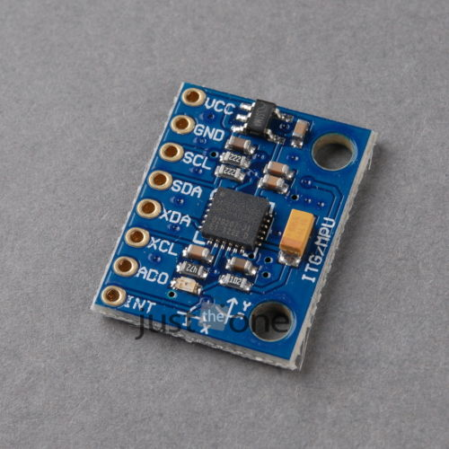

# **MPU-6050 3 Axis Gyroscope+Acce​lerometer Module(3V-5V compatible)**

**Description:**

**1. Chip: MPU-6050**

**2. Power supply: 3v-5V power**

**3. Gyroscope range: +/-250 500 1000 2000°/s**

**4. Acceleration range: +/-2 +/-4 +/-8 +/-16g**

**5. Communication: standard IIC communication agreement**

**6. Chip built-in 16 bit AD converter, 16 bits of data output**

**7. Pin spacing 2.54mm**

**Color: Black, show as pictures**

**PLS NOTE that due to lighting effects, monitor's brightness / contrast settings etc, it could be some minor differences in the hue of the images and the actual item**

**Package Included:**

**2pcsx 3 Axis Gameyroscope**

**2pcs x 3 Axis Acce​lerometer Modul**

# **DC DC Converter Module 12V To 5V 3A 15W Duble USB Output Power Adapter ECDC DC Converter Module 12V To 5V 3A 15W Duble USB Output Power Adapter EC**

100% brand new and high quality

Quantity:1PC

Input voltage: DC 12 V(12V To 5v)

(Input Voltage must Higher 3V than Output Voltage)

Output voltage: 5V

Output Current: 3A

Power :15w

Conversion efficiency: 96%

Size :46mmX26mmX14mm/1.81''X1.02''X0.55''

# ST- Link V2 Mini Metal Shell STM8 STM32 Emulator Downloader Programming Best**ST- Link V2 Mini Metal Shell STM8 STM32 Emulator Downloader Programmin**

NOTE: Color random delivery.

1. Red and blue double color LED indicator light, convenient you always observes the working state of the ST-link V2.

2. 5V,3.3V available at the same time.

3. Support the full range of STM32 SWD debugging interface, a simple 4-wire interface (including power), fast, stable; interface definition housing directly marked! Do not need to read the manual.

4. Support the full range of STM8 SWIM download debugging (common development environments such as IAR, STVD etc. are supported); supported software versions as follows:

① ST-LINK Utility 2.0 and 4.2.1 above.

② STVD and above.

③ STVP 3.2.3 and above.

④ IAR EWARM V6.20 and above.

⑤ IAR EWSTM8 V1.30 and above.

⑥ KEIL RVMDK V4.21 and above.

5. Support for automatic firmware upgrades to ensure follow-up support ST products. The factory firmware has been upgraded to the latest V2.J17.S4.

6. Increase the 5V power output, the output I / O ports are protected afraid of operational errors caused by ST-LINK V2 damage.

7. The interface easy to use copper gilded horns seat pitch of 2.54, with 20CM DuPont line, the line can respond to different target sequence, flexible wiring.

8. The use of U disk aluminum housing protects the motherboard, easy to carry, is not afraid of static electricity, afraid to fall throw touch.

Package Included:

1. 1×ST- Link V2 Mini Metal Shell STM8 STM32 Emulator Downloader Programming Unit.（Anti-static bag sealed packaging）

2. 1×20cm dupont line.（Anti-static bag sealed packaging）

# Development Board Minimum System Board ARM STM8 STM8S103F3P6 Module for Arduino**Development Board Minimum System Board ARM STM8 STM8S103F3P6 Module**

**Description:**

* **STM8S Core Board of the Highlights:**
* The development board using Micro USB cable supply, compatible with smart phone lines, data lines is simple and easy to get, but not USB Mini line-powered
* Low price, user-friendly design, a full set of data, allowing you to save money, save time, effort, worry
* **STM8S core board of the main features:**
* Use STM8S103F3P6 as the master IC
* You can use 2.54 pin on the board or power supply pad, the pad when using power supply, input voltage range 4.5V-15V, can output to the outside through pin 3.3V
* Note:5V pin's voltage is the input voltage of the module
* Leads to all pins, the pins next to the pin marked the label, with a reset button, power LED, and the program demonstrates LED, small but perfectly formed
* Support SWIM debug mode
* **Technical Information:**
* The core board schematics (PDF format) and tested source. Burned into the test program, LED flashes, allowing you to detect the core board is working properly
* Provide at IAR and STVD two development environments register operation and routine operation of the library functions. Timer routine, UART transmit routine, UART receive routines, clock switching routines, AD routines and so on
* STM8 Applications
* STM8 package library
* IAR development environment, STVP programming software
* **STM8S103F3P6 performance comparison:**
* STM8S003F3 chips only 128 bytes of EEPROM, STM8S103F3 640 bytes
* STM8S003F3 chip FLASH erase only 100 times, STM8S103F3 can erase ten thousand times
* STM8S103F2 chip FLASH only 4K bytes, STM8S103F3 have 8K bytes
* Conclusion: STM8S003F3 only suitable for mature products, STM8S003F3 core board is not suitable for development. However STM8S103F3 suitable for the development of the use of, our board of this development is the use of this chip
* Size:28mm*17mm*5mm/1.1*0.66*0.19"
* Quantity:1 pc

**Package includes:**

* **1 x STM8 Development Board**

|  |
| --- |

# ESP8266 ESP-05 + Antenna Simple Serial WIFI**ESP8266 ESP-05 + Antenna Simple Serial WIFI**

**ESP8266 ESP-05 + Antenna Simple Serial WIFI**

You can get 1 piece of ESP8266 low cost **Serial WiFi module to connect any of your projects to the world of Internet for only $2.95 (USD), shipped within 3 business days. Simple to use with simple wiring on** the 4x2 male header and simple 3 wires serial **communication at 9600/8/N/1 at TTL level.**

The following are the major features:

**1. Support 802.11 B/G/N**

2. Communication range up to 100 yards depending on environment.

3. Standard 3.3VDC operation with 5V compatible I/O.

4. Standard 3 wire (TXD/RXD/GND) serial communication (idle high) at 9600/8/N/1.

5. Standard 0.1" (2.54mm) 4x2 header. (Other form factor available)

6. Upgradeable firmware.

7. Three mode of operations: Client/Access Point/Both Client and Access Point.

8. Support all major security schemes: OPEN/WEP/WPA_PSK/WPA2_PSK/WPA_WPA2_PSK.

9. Support both TCP and UDP communication.

10. Working as TCP/UPD server supports up to five (5) connections.

11. Working as station can connect up to 5 TCP/UPD servers. The ESP-05 can connect to all standard non-SSL websites in the world.

12. On board antenna. (Other modules can support external antenna for enhanced communication and extended range)

13. Simple AT commands for all operations.

14. Connection based data reception or transparent data reception.

15. Programmable client connection inactivity timeout.

16. Automatic domain name address resolution for public domain name but not the local name within the local area network (router).

17. Detailed English user manual in PDF format upon request via email.

This listing is for a standard Serial WiFi module (ESP-05) as shown in the listing photo.

The following is the connection pinout for this module:

1. GND - ground

2. URXD - serial transmit (idle high)

3. UTXD - serial receive (idle high)

4. VCC - 3.3VDC

The following is the list of AT commands:

1. AT-Attention

2. AT+RST-Soft reset

3. AT+GMR-Retrieve firmware version

4. AT+CWMODE-Operation mode selection

5. AT+CWJAP-Join network

6. AT+CWLAP-Available network listing

7. AT+CWQAP-Exit network

8. AT+ CWSAP-Setup network name, password, radio channel and security scheme

9. AT+ CWLIF-Listing connected stations

10. AT+ CIPSTATUS-Connection listing

11. AT+CIPSTART-Initiating connection

12. AT+CIPSEND-Sending data

13. AT+CIPCLOSE-Closing connection

14. AT+CIFSR-Displaying IP from access point

15. AT+CIPMUX-Single or multiple connection selection

16. AT+CIPSERVER-Socket server on/off

17. AT+CIPMODE-Serial port transparent or connecdtion based data output selection

18. AT+CIPSTO-Socket server automatic connection timeout setting

19. +IPD-Serial port connection based data output

**The ESP-05 is a serial device at TTL level not RS232 level. If you need to connect the ESP-05 to a RS232 serial port, you will need have a RS232 level converter with MAX232 or compatible device.**

Should you have different requirements for serial WiFi, we will be **glad to design your custom Serial WiFi module using the same low cost and reliable technology to meet your needs for a low minimum order quantity requirement. Please feel free to contact us for details.**

Item included as follow:

1. 1 x ESP-05 Serial WiFi module with 5x1 header

2. **1x 2.4G Antenna for ESP8266 Serial WiFi module with hardware as shown in the photo**

**3. Detail English User Manual in PDF format upon request**

# Micro SD Storage Board Mciro SD TF Card Memory Shield Module SPI For Arduino**Micro SD Storage Board Mciro SD TF Card Memory Shield Module SPI For Arduino**

Specification:

The module (MicroSD Card Adapter) is a Micro SD card reader module, and the SPI interface via the file system driver, microcontroller system to complete the MicroSD card read and write files. Arduino users can directly use the Arduino IDE comes with an SD card to complete the library card initialization and read-write

Module features are as follows:

1 Support Micro SD Card, Micro SDHC card (high-speed card)

2 the level conversion circuit board that can interface level is 5V or 3.3V

3 power supply is 4.5V ~ 5.5V, 3.3V voltage regulator circuit board

4. Communication interface is a standard SPI interface

5. 4 M2 screw positioning holes for easy installation

Control Interface: A total of six pins (GND, VCC, MISO, MOSI, SCK, CS), GND to ground, VCC is the power supply, MISO, MOSI, SCK is the SPI bus, CS is the chip select signal pin;

3.3V regulator circuit: LDO regulator output 3.3V as level converter chip, Micro SD card supply;

Level conversion circuit: Micro SD card into the direction of signals into 3.3V, MicroSD card toward the direction of the control interface MISO signal is also converted to 3.3V, general AVR microcontroller system can read the signal;

Micro SD card connector: yes since the bomb deck for easy card insertion and removal.

Positioning holes: 4 M2 screws positioning hole diameter of 2.2mm, the module is easy to install positioning, to achieve inter-module combination;

# 1m PL2303HX Download Cable USB To COM USB to TTL Converter Cable**PL2303HX Download Cable USB To COM USB to TTL Converter Cable**

* Brand new and high quality

* Supports baud rate from 75 to 128000

* Support Linux, Mac OS, WinCE and Windows (XP, Vista Win 7 inc 64 Bit Edition)

* PL2303HX USB to Serial Controller adopted<./li>

* 4 connecting wires, 2.54mm pitch type

* Red Wire == VCC, (+5V)

* Black Wire ==GND

* Green Wire == TXD

* White Wire == RXD

* Length: Approx 1M

# Leonardo Pro Micro ATmega32U4 Arduino IDE 1.0.3 Bootloader replace Pro Mini**Leonardo Pro Micro ATmega32U4 Arduino IDE 1.0.3 Bootloader replace Pro Mini**

***Description***

100% Brand New

**The Pro Micro is similar to the Pro Mini except with an ATmega32U4 on board. The USB transceiver inside the 32U4 allows us to add USB connectivity on-board and do away with bulky external USB interface.**

**This tiny little board does all of the neat-o Arduino tricks that you're familiar with: 4 channels of 10-bit ADC, 5 PWM pins, 12 DIOs as well as hardware serial connections Rx and Tx. Running at 16MHz and 5V, this board will remind you a lot of your other favorite Arduino-compatible boards but this little guy can go just about anywhere. There is a voltage regulator on board so it can accept voltage up to 12VDC. If you're supplying unregulated power to the board, be sure to connect to the "RAW" pin on not VCC.**

**This latest revision corrects the silk error from the last version of the board so that pin 14 is correctly labeled. We've also added a PTC fuse and diode protection to the power circuit and corrected the RX and TX LED circuit.**

**Dimensions: 1.3x0.7"**

**Features:**

* **ATMega 32U4 running at 5V/16MHz**
* **Supported under Arduino IDE v1.0.1**
* **On-Board micro-USB connector for programming**
* **4 x 10-bit ADC pins**
* **12 x Digital I/Os (5 are PWM capable)**
* **Rx and Tx Hardware Serial Connections**
* **Our Smallest Arduino-Compatible Board Yet!**

# 1x DIY ATmega328P CH340G UNO R3 USB Development Board Pad Module Kit For Arduino**ATmega328P CH340G UNO R3 USB Development Board**

Features:

This version is optimized in the original version to ensure consistent and compatible with the original, but also easy to use

Compatible with win7 and win8

Increase the pin socket, to facilitate the use of DuPont line

Replaced 16u2 By CH340

Digital I/ O Digital Inputs/ Outputs: 0-13

Analog I/ O Analog Input/ Output: 0-5

Support ISP download function

The Input Voltage: no external power supply when connected to the computer USB, external power supply: 5V-9V DC

Output Voltage: 3.3V and 5V DC voltage output

Using Atmel Atmega328 micro controller

Board Size: Approx. 7.2cm x 5.3cm x 1.5cm/ 2.83" x 2.09" x 0.59"

Package Included:

1 x ATmega328P CH340G Board

# Iteaduino Lite LGT8F88A Development Board Perfect Compatible Arduino**Iteaduino Lite LGT8F88A Development Board**

Overview:

Iteaduino Lite is a new Arduino mainboard based on LGT8F88A compatible with Arduino interfaces. With 14 digital input and output pins (of which 6 pins can be used for PWM output), 6 analog inputs and SWD debug interface, the operating frequency can reach up to 32MHz. Compared to other Arduino mainboards, it runs faster with more powerful functions. It is compatible with most of Arduino libraries, and the development is as simple as Arduino.

Features:

1. Adopting LGT8F88A chip

2. GPIO interface breaks out electronic brick interface

3. Adopting high-efficiency DCDC supply with wider input range

4. Selectable operating level: 3.3V/5V

Specification:

Microcontroller:LGT8F88A

Max Frequency:32MHz

RAM Capacity:1K

FLASH Capacity:8K

External Resources:No

Power Supply:7~24V DC

I/O Operation Level:3.3V/5V

Board Size:68.6mm X58.5mm X 1.6mm

Accessories:No

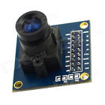OV7670 300KP VGA Camera Module for Arduino

**Model**3100025**Quantity**1**Color**Black + blue**Material**PCB + plastic + metal**Features**Photosensitive Array: 640 x 480; IO Voltage: 2.5V to 3.0V; Operating Power: 60mW/15fpsVGAYUV; Sleeping Mode: <20 uA; Operating Temperature: -30 to 70 deg C.; Output Format: YUV/YCbCr4:2:2 RGB565/555/444 GRB4:2:2 Raw RGB Data (8 digit);

Lens Size: 1/6"; Vision Angle: 25 degree; Max. Frame Rate: 30fps VGA; Sensitivity: 1.3V / (Lux-sec); Signal to Noise Ratio: 46 dB; DynamicRange: 52 dB; Browse Mode: By row; Electronic Exposure: 1 to 510 row; Pixel Coverage: 3.6um x 3.6um; Duck Current: 12 mV/s at 6'C**Application**High sensitivity for low-light operation; Low operating voltage for embedded application; Standard SCCB interface compatible with I2C interface; Raw RGB, RGB (GRB4:2:2, RGB565/555/444),YUV(4:2:2) and; YCbCr(4:2:2)output format; Support VGA, CIF and from CIF to 40 x 30 format; Vario Pixel method for sub-sampling; Auto Image Control: AEC, AGC, AWB, ABF, ABLC; Image Quality Control: Color saturation, hue, gamma, sharpness and anti-blooming; ISP includes noise reduction and defect correction; Support image scaling; Lens shading correction; Flicker 50/60Hz auto detection; Color saturation level auto adjust; Edge enhancement level auto adjust; De-noise level auto adjust**Packing List**1 x Camera module Dimensions: 1.38 in x 1.34 in x 1.02 in (3.5 cm x 3.4 cm x 2.6 cm)

Weight: 0.46 oz (13 g)

sku: 07010623

# 2Pcs U Disk Read Write Module ICSJ021A Supply SPI host interface 6MHz CH376S**U Disk Read Write Module ICSJ021A Supply SPI host interface 6MHz CH376S**

1. The CH376 chip internal curing FAT file system, file operation is simple, fast,

2. Support U disk, USB hard disk, USB flash drive and USB card reader, USB storage device

3. Standard Capacity SD card support, high capacity HC-SD card as well as protocol-compatible MMC, TF card

4. Support a variety of communication interfaces: 8-bit parallel, SPI interface and asynchronous serial

5. Compatibility: Equipment manner compatible with CH372 compatible host with CH375

6. Module size: 50mm × 34mm

**Package included：**

* 2 x U Disk Read Write Module ICSJ021A Supply SPI host interface 6MHz CH376S

Fantastic information about this device can be found here:

<http://arduinobasics.blogspot.com/2015/05/ch376s-usb-readwrite-module.html>

# NodeMcu Lua WIFI Internet of Things development board based ESP8266 module**NodeMcu Lua WIFI Internet of Things development board based ESP8266 module**

1. ESP8266 has IO Pin

2. No need to download resetting!

3. A great set of tools to develop ESP8266!

**[Data download](http://www.nodemcu.com/index_en.html)**

**[Hardware and software open source](http://bbs.nodemcu.com/)**

**Package Included:**

1 x NodeMcu Lua WIFI Internet of Things development board based ESP8266 TOP

# 1 Pcs CD74HC4067 Analog Digital MUX Breakout Board Compatible For Arduino **CD74HC4067 Analog Digital MUX Breakout Board Compatible For Arduino**

Description:

1. This is a breakout board for the very handy 16-Channel Analog/Digital.

2. This chip is like a rotary switch - it internally routes the common pin (COM in the schematic, SIG on the board) to one of 16 channel pins (CHANxx).

3. It works with both digital and analog signals (the voltage can’t be higher than VCC), and the connections function in either direction.

4. To control it, connect 4 digital outputs to the chip’s address select pins (S0-S3), and send it the binary address of the channel you want (see the datasheet for details). This allows you to connect up to 16 sensors to your system using only 5 pins!

5. Since the mux/demux also works with digital signals, you can use it to pipe TTL-level serial data to or from multiple devices. For example, you could use it to connect the TX pins of 16 devices to one RX pin on your microcontroller. You can then select any one of those 16 devices to listen to. If you want two-way communications, you can add a second board to route your microcontroller’s TX line to 16 device’s RX lines. By using multiple boards, you can create similar arrangements for I2C, SPI, etc.

6. The internal switches are bidirectional, support voltages between ground and VCC, have low “on” resistance and low “off” leakage, and to prevent crosstalk, perform “break-before-make” switching. The board also breaks out the chip’s “enable” pin, which when driven high, will completely disconnect the common pin (all switches “off”).

Features:

1. 2V to 6V operation.

2. "O" resistance: 70 Ohms @ 4.5V.

3. 6ns break-before-make @ 4.5V.

4. Wide operating temperature range: -55C to 125C.

Packing Included:

1 x CD74HC4067 Analog Digital MUX Breakout Board Compatible Arduino

# VK2828A8G5 G-Mouse GPS Module GPS Navigation Board w/TTL Level Antenna**VK2828A8G5 G-Mouse GPS Module GPS Navigation Board w/TTL Level Antenna**

**VK2828A8G5 Specification:**

- C/A code: 1.023MHz

- Receive frequency: L1[1575.42MHz]

- Follow channel: 24

- Support DGPS[WAAS, EGNOS and MSAS]

**Position performance:**

- 2D dimension: 5m

- 2D dimension: 3.5m, with DGPS

- Drift: <0.02m/s

- Time precision: 1us

- Coordinate system: WGS-84

- Max.altitude: 18000m

- Max.acceleration 500m/s

- Accelerator: <4g

**Electronic performance:**

- Follow sensitivity: -161dBm

- Capture sensitivity: -153dBm

- Hot start: 1s

- Warm start: 37s

- Cold start: 39s

- Recapture time: 0.1s

**Operation temperature**: -30ï½+80â

**Size:** 28*38*8.4mm, cable length 2m

**Port Electronics:**

- Wide voltage range: +3.5V~+5.0V

- With 25*25*4 ceramic antenna

- Output baud rate: 9600bps

- Output GGA, GLL, GSA, GSV, RMC data

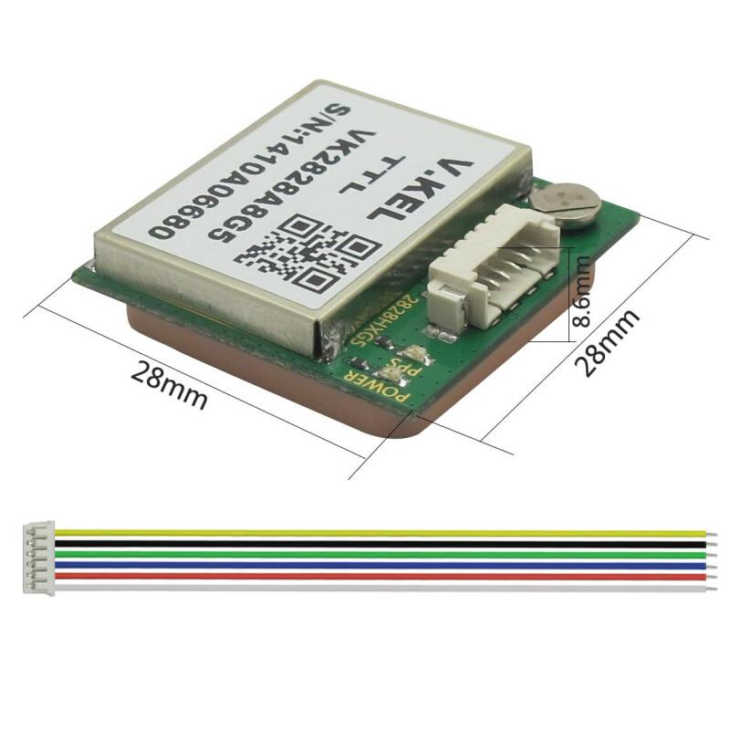

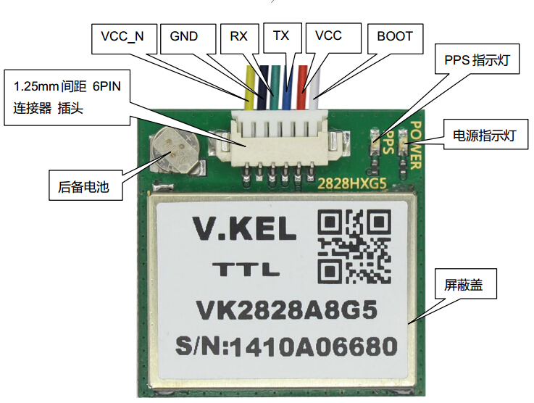

Package Including:

1. 6pin 15cm dupont cable

2. VK2828A8G5 G-Mouse GPS Module GPS Navigation Board

# s-l140.jpg**WS2812 5050 RGB LED Driver Module Board for Arduino**

| **Description:** | |
| --- | --- |
| * **100% brand new and high quality** * Intelligent reverse connect protection, the power supply reverse connection does not damage the IC. * The control circuit and the LED share the only power source. * Control circuit and RGB chip are integrated in a package of 5050 components, form a complete control of pixel point. * Built-in signal reshaping circuit, after wave reshaping to the next driver, ensure wave-form distortion not accumulate. * Built-in electric reset circuit and power lost reset circuit. * Each pixel of the three primary color can achieve 256 brightness display, completed 16777216 color full color display, and scan frequency not less than 400Hz/s. * Cascading port transmission signal by single line. * Any two point the distance more than 5m transmission signal without any increase circuit. * When the refresh rate is 30fps, cascade number are not less than1024 points. * Send data at speeds of 800Kbps.] * The color of the light were highly consistent, cost-effective.. * Size:5.5cm x 1cm(approx.) * **Applications** * Full-color module, Full color soft lights a lamp strip. * LED decorative lighting, Indoor/outdoor LED video irregular screen. | |
| **Package includes:** | |
| * **1 x WS2812 5050 RGB LED Module for Arduino** | |

# BlueDuino Rev2 Arduino Compatible Plus BLE CC2540**BlueDuino Rev2 Arduino Compatible Plus BLE CC2540**

### BlueDuino Rev2 with cc2540 BLE module

#### **What is it?**

The BlueDuino Rev2 is an Arduino compatible microcontroller development board based on the ATmega32U4 IC with Bluetooth 4.0. a.k.a. Bluetooth Low Energy (BLE), built in. Just plug in the board and your ready to start programming! It's the easiest way to get Bluetooth 4.0 in your project!

The BlueDuino Rev2 is tiny size Arduino compatible dev board. It's built-in a cc2540 BLE module. The BLE module can work as master or slave mode.

#### **Features**

* Built-in CC2540 BLE module
* ATmega32U4 running at 3.3V/8MHz
* Supported under Arduino IDE 1.0.6
* On-Board micro-USB connector for programming
* 4 x 10-bit ADC pins
* 12 x Digital I/Os (5 are PWM capable)
* Rx and Tx Hardware Serial Connections

#### **Firmware For CC2540**

The firmware for CC254x BLE module named [ZeroBeacon](http://wiki.aprbrother.com/wiki/Firmware/ZeroBeacon).

* Support iBeacon features
* Support UART transparent transfer.
* Support AT commands
* Support upgrade the firmware by serial port.

#### **Getting Started**

Open Arduino IDE and choose board "LilyPad USB" to start playing with your BlueDuino Rev2 in just a few easy steps.

#### **How it works**

The CC254x module communicates with ATMega32U4 through the HardwareSerial Serial1 (RX1, TX0).

#### **Package contains**

* BlueDuino Rev2 x 1
* Male headers (Not soldering) x 1

More information please refer [our wiki](http://wiki.aprbrother.com/wiki/BlueDuino_rev2).

# Color Image LCD Shield for Arduino Nokia 6100 Display Board**Color Image LCD Shield for Arduino Nokia 6100 Display Board**

# **Product Description**

**This is a shield board with nokia 6100 LCD.**

**This 128x128 mini color LCD is a perfect match for the portable application. It is designed to repalce a broken screen in a cell phone. So the connector was not designed for multiple attachment/detachment. Please be gentle and handle with care.**

**This inexpensive LCD comes with a powerful white LED backlight and a relatively simple serial interface. It's a 9-bit interface, so beware. But we were able to get the LCD up and running on a LPC2138 with a few hours worth of work.**

**Frame Dimensions:1.35x1.58"**

**Active Display Dimensions:1.2"x1.2"**

## Specification

## LCD Logic - 3.3V @ 2-3mA

## LED Backlight - 7V @ 40-50mA (very bright)

## Full 4,096 Color Display

## Uses thePhilips PCF8833Controller

## 

## Documents:

## Latest LPC2148example code from SFE, works with both controllers

## Latest ATmega8 examplecode from SFE, works with Epson controller

## Interface tutorial

## Epson ControllerDatasheet

## SFE Eagle Libraryhas this part!

## Theholy grail forum postingfor this Nokia type LCD

## Example Pixel Control of LCD

## Example Parallax Stamp BS2 Code

## Example ATMega32 Code

## Example SAM7-P64 ARM Code

## Example 3D Graphics projecton a PIC

## Example ATMega644/128/32/16 code

## Example Gumstix Interface

## Example PIC 16F87x codefor CCS Compiler

## Example PIC 18F4550 USB

## Example 4096 Color Control

## Example Linux Driver

## Example Image Converter

## Bit map Converter

## mbed Example

## 

## Pin Out (use the numbering visible on the display connector):

## VCC-Digital (3.3V)

## RESET

## SDATA

## SCK

## CS

## VCC-Display (3.3V)

## N/C

## GND

## LED GND

## LED V+ (6-7V)

## 

## Technical support

## 

## [Schematics](http://www.cutedigi.com/pub/Shield/nokia_LCD_shield_sch.pdf)

## [Sample Arduino Code](http://www.cutedigi.com/pub/Shield/NOKIA_LCD_SHIELD.rar)

## [arduino code base](http://www.lillyelectronics.com/download/arduino%20code.rar)

Nokia 6100 LCD Display driver

## You need to change the code into the Philips drive.

## arduino code library that contains two drive EPSON and PHILLIPS, choose to use, you can adjust the parameters for the dark color and light in the code. Toning without the use of keys. Our LCD chip using PHILLIPS choose in your code:

## 

## Choose one of them, the starting position and orientation of the four pictures to choose from.

## 

## // For a Phillips Screen:

## // This

## graphic.begin (0,0,0, PHILLIPS_0); // Normal X direction

## // or

## //graphic.begin(0,0,0,PHILLIPS_1); // Revesed X direction.

## // or

## //graphic.begin(0,0,0,PHILLIPS_2); // Normal X direction, Mirrored.

## // or

## //graphic.begin(0,0,0,PHILLIPS_3); // Revesed X direction, Mirrored.

## 

## graphic.Contrast (0x3F); // make the color clear, clear,> 0x30

## You can see this after you run the code on your arduino

**Items package**

Color Image LCD empty Shield*1

Nokia 6100 LCD*1

# A4988 Stepper Motor Driver Module 3D Printer Polulu StepStick RAMPS RepRap**A4988 Stepper Motor Driver Module 3D Printer Polulu StepStick RAMPS RepRap**

A4988 is a complete microstepping motor driver with built-in translator for easy operation. This product is available in full, half, 1/4, 1/8 and 1/16 step modes operate bipolar stepper motors, output drive capacity of up to 35 V and ± 2 A. A4988 includes a fixed off-time current regulator, the regulator is able to operate in slow or mixed decay modes. Converter is A4988 easy implementation of the key. As long as the "step" input inputting one pulse drives the motor one microstep. There are no phase sequence tables, high frequency control lines, or complex interfaces to program. A4988 interface is very suitable for complex microprocessor is unavailable or is overburdened.

Features:

Low RDS (ON) output

Automatic current decay mode detection / selection

Mixed with slow current decay modes

Synchronous rectification for low power dissipation

Internal UVLO

Crossover-current protection

3.3 and 5 V compatible logic supply

Thermal shutdown circuitry

Ground fault protection

Load short-circuit protection

Step five selectable modes: full, 1/2, 1/4, 1/8 and 1/16

# CNC Shield V3 Expansion Board A4988 Stepper Motor Driver 3D printer for Arduino**CNC Shield V3 Expansion Board A4988 Stepper Motor Driver 3D printer for Arduino**

**Item Description:**

* This expansion board as a driver expansion board, can be used for engraving machines, 3D printers
* It is a total of four slots, can drive four A4988 stepper motor. Each road stepper motors only need two IO ports. In other words, six IO ports can be well managed

Features:

* The correspondence between Arduino UNO and this module IO port
* 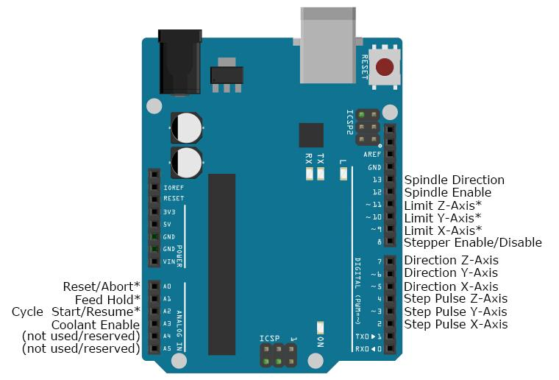

Note:

* When inserting the A4988 module, must be careful not to insert opposite. Stepper motor wiring as follows:2A, 2B is a group (red, green), 1A, 1B is a group (blue, yellow), if want to change direction, can be change the position of one group , for example 2A, 2B mutually exchanged

# 1PCS A4988 Driver 3D Printer Module Motor Reprap+Self-adhensive Stepper Heatsink**A4988 Driver 3D Printer Module Motor Reprap+Self-adhensive Stepper Heatsink**

**Features**:

3D Printer Module;

low RDS (on) output;

Automatic current attenuation mode detection/ choice;

Mixed and slow current attenuation model;

Low power dissipation synchronous rectifier;

Internal UVLO;

Crossover-current protection;

3.3 and 5V compatible logic power supply;

Overheating shutdown circuit;

Grounding short circuit protection;

Load short circuit protection;

Five optional step mode: full, 1/2, 1/4, 1/8 and 1/16;

**Condition**:New

**Color**:Show as pictures.

**Note:Due to lighting effects, monitor's brightness/ contrass settings ect, there could be some slight differences in the color tone of the pictures and the actual item!**

**Package Included**: 1 x 3D Printer Module

# New 3V-5V HMC5883L Triple Axis Compass Magnetometer Sensor Module For Arduino**3V-5V HMC5883L Triple Axis Compass Magnetometer Sensor Module For Arduino**

Brand new and high quality.

HMC5883L module (three-axis magnetic field module).

Use the chip: HMC5883L.

Power supply: 3-5V.

Communication modes: standard IIC communication protocol.

Measuring range: ± 1.3-8 Gauss.

Size: 1.5cm x 1.8cm.

1 x HMC5883L Compass Magnetometer Sensor Module

NO Retail Box. Packed Safely in Bubble Bag

# New 433Mhz RF transmitter receiver link kit for Arduino/ARM/MC​U remote control**433Mhz RF transmitter receiver link kit for Arduino/ARM/MC​U remote control**

TX Technical Specifications:

Receiver module parameters

1.Product Model: MX-05V

2.Operating voltage: DC5V

3.Quiescent Current: 4mA

4.Receiving frequency: 433.92MHZ

5.Receiver sensitivity:-105DB

6.Size: 30 * 14 * 7mm

7.External antenna: 32CM single core wire, wound into a spiral

Technical parameters of the transmitter head

1.Product Model: MX-FS-03V

2.Launch distance :20-200 meters (different voltage, different results)

3.Operating voltage :3.5-12V

4.Dimensions: 19 * 19mm

5.Operating mode: AM

6.Transfer rate: 4KB / S

7.Transmitting power: 10mW

8.Transmitting frequency: 433M

9.An external antenna: 25cm ordinary multi-core or single-core line

10.Pinout from left → right: (DATA; VCC; GND)

Application environment

Remote control switch, receiver module, motorcycles, automobile anti-theft products, home security products, electric doors, shutter doors, windows, remote control socket, remote control LED, remote audio remote control electric doors, garage door remote control, remote control retractable doors, remote volume gate, pan doors, remote control door opener, door closing device control system, remote control curtains, alarm host, alarm, remote control motorcycle remote control electric cars, remote control MP3.

Remark

1.VCC voltage module operating voltage and good power filtering;

2.Great influence on the antenna module reception, preferably connected to the 1/4 wavelength of the antenna, typically 50 ohm single conductor, the length of the antenna 433M of about 17cm;

3.Antenna position has also affected the reception of the module, the installation, the antenna as possible straight away from the shield, high pressure, and interference source; frequency used to receive, decode and oscillation resistor should match with the transmitter.

# L9110S Dual DC Stepper Motor Driver Controller Module PWM H-Bridge for Arduino**L9110S Dual DC Stepper Motor Driver Controller Module PWM H-Bridge**

* **100% brand new and high quality**
* Motor drive of double L9110S chip
* Supply Voltage: 2.5-12V
* Suitable Range: Working voltage between 2.5-12V, the max working current is 0.8A
* It can drive 2 direct current machines at the same time, or 1pc two-phase 4-wire stepping motor
* PCB Board Size: Approx. 2.8 x 2.1cm / 1.1 x 0.83 inch (ultra small volume, easy to assemble)
* It has fixed installation holes, and diameter is 3mm
* **Module port specification:**
* **6pcs yellow pins:**
* VCC --2.5V-12V voltage
* GND --GND
* IA1—singlechip IO port
* IB1-- singlechip IO port
* IA2-- singlechip IO port
* IB2-- singlechip IO port
* **4pcs blue ports:**
* OA1 OB1 connect 2pcs pins of DC Motor, directionless
* OA2 OB2 connect2pcs pins of DC Motor, directionless
* **Module instructions:**
* Power indicator light is on if you connect VCC and GND
* IA1 input high level, 1A1 input low level, (OA1, OB1) Motor corotates
* IA1 input low level, 1A1 input high level, (OA1, OB1) Motor reverses
* IA2 input high level, IA2 input low level, (OA2, OB2) Motor corotates
* IA2 input low level, IA2 input high level, (OA2, OB2) Motor reverses
* Quantity: 1pc

# L298N Dual H Bridge DC Stepper Motor Drive Controller Board Module For Arduino**L298N Dual H Bridge DC Stepper Motor Drive Controller Board Module**

**Features:**

* L298N as main chip,ST corporation production.
* Low heat,outstanding anti-interference performance.
* High working power to 46v,large current can reach 3A MAX and continue current is 2A, power to 25w.
* Can drive one 2-phase stepper motor, one 4-phase stepper motor or two DC motors.
* Built-in 78M05,get power from drive power,however, when drive power over 12V, please use the external 5v power as power supply.
* Large capacity filter capacitance,afterflow protection diode, more stable and reliable.

**Specification:**

* Double H bridge drive
* Chip: L298N (ST NEW)
* Logical voltage: 5V
* Drive voltage: 5V-35V
* Logical current: 0mA-36mA
* Drive current: 2A(MAX single bridge)
* Max power: 25W
* Size:43 x 43 x 26mm(LxWxH)

**Note:**

* This module has a built-in 5v power supply, when the driving voltage is 7v-35v, this supply is suitable for power supply
* DO NOT input voltage to +5v supply interface, however leading out 5v for external use is available.
* When ENA enable IN1 IN2 control OUT1 OUT2
* When ENB enable IN3 IN4 control OUT3 OUT4

**Package Included:**1 x L298N dual H bridge module

# 5pcs HC-SR501 Adjust IR Pyroelectric Infrared PIR Motion Sensor Detector Module **HC-SR501 Adjust IR Pyroelectric Infrared PIR Motion Sensor Detector Module**

**Product Description**:

Product Type: HC--SR501 Body Sensor Module

Operating voltage range: DC 4.5-20V

Quiescent Current: <50uA

Level output: High 3.3 V /Low 0V

Trigger: L can not be repeated trigger/H can be repeated trigger(Default repeated trigger)

Delay time: 5-200S(adjustable) the range is (0.xx second to tens of second)

Block time: 2.5S(default)Can be made a range(0.xx to tens of seconds

Board Dimensions: 32mm*24mm

Angle Sensor: <100 ° cone angle

Operation Temp: -15-+70 degrees

Lens size sensor: Diameter:23mm(Default)

Features:

1, the automatic sensor: to enter the sensor output range is high, people leave the sensor range of the automatic

delay off high, output low.

2,the photosensitive control (optional, factory is not set) may set the photosensitive control during the day or

light intensity without induction.

3, the temperature compensation (optional, factory is not set): In the summer when the ambient temperature rises

to 30 ~ 32 ℃, slightly shorter detection range, temperature compensation can be used as a performance compensation.

4, two trigger mode: (can be selected by jumpers)

a, can not repeat the trigger: the sensor output high, the delay time is over, the output will automatically

become low from high;

b, repeatable trigger: the sensor output high after the delay period, if the human body in its sensing range

activities, its output will remain high until after the delay will be left high to low (sensor module review

Measured activities of each body will be automatically extended after a delay time, and the final event of

the delay time Starting point of time).

5, with induction blocking time (the default setting: 2.5S block time): sensor module, after each sensor output

(high change Into a low level),you can set up a blockade followed by time period, in this time period the sensor

does not accept any sensor signal. This feature can have a "sensor output time" and "blocking time" the interval

between the work produced can be applied to detect the interval Products; also inhibit this function during load

switching for a variety of interference. (This time can be set at zero seconds - Tens of seconds).

6, the working voltage range: the default voltage DC4.5V-20V.

7, micro-power consumption: static current "50 microamps, especially for battery-powered automatic control products.

8, the output high level signals: types of circuits can be easily and docking.

Instructions:

1. Sensing module for about a minute after power initialization time, during the interval to the output module

0-3 times a minute in standby mode.

2. Should avoid direct lighting such as interference sources close the surface of the lens module so as to avoid the

introduction of interference signal generator malfunction; use of the environment to avoid the flow of the wind, the

wind sensor will also cause interference.

3. Sensor module using a dual probe, the probe's window is rectangular, dual (A per B million) in the direction of

the ends of long, when the body passed from left to right or right to left when the reach the dual IR time, distance

difference, the greater the difference, more sensitive sensors, when the body from the front to the probe or from top

to bottom or from bottom to top direction passing, dual IR not detected changes in the distance, no difference value,

the sensor insensitive or does not work; so the sensors should be installed dual direction of the probe with human

activities as much as possible parallel to the direction of maximum to ensure that the body has been passed by the

dual sensor probe. To increase the sensing range of angles, the module using a circular lens, the probe also makes sense

on all four sides, but still higher than the upper and lower left and right direction of sensing range, sensitivity and

strong, still as far as possible by the above installation requirements.VCC, trig (control side), echo (receiving end), GND

4. Dimensions and Adjustment:

Note: The potentiometer clockwise to adjust the distance, sensing range increases (about 7 meters), on the contrary,

sensing range decreases (about 3 meters).Delay adjustment potentiometer clockwise rotation, sensor delay longer (about 300S),

the other hand, induction by the short delay (about 5S).

5. Applications

a, Security Products

b, the human body sensors toys

c, the human body sensor lighting

d, industrial automation and control, etc.

It can automatically and quickly open various types of incandescent, fluorescent lamps, buzzer, automatic doors,

electric fans,automatic washing machine and dryer Machines and other devices,is a hightech products. Especially

suitable for enterprises, hotels, shopping malls, warehouses and family aisles, corridors and other sensitive

Sense of region, or for the security zone automatic lighting, lighting and alarm systems.

# 10x CD4051BE DIP-16 Analog Multiplexers/Demultiplexers Hot Sale**CD4051BE DIP-16 Analog Multiplexers/Demultiplexers**

# 5PCS Infrared reflective Photoelectric Switch IR Barrier Track sensor TCRT5000L**Infrared reflective Photoelectric Switch IR Barrier Track sensor TCRT5000L**

# Practical USB Nano V3.0 ATmega328P 5V Micro-controller board Arduino Compatiable**Infrared reflective Photoelectric Switch IR Barrier Track sensor TCRT5000L**

Product Summary:

CH340G Replace FT232RL

Operating Voltage(logic level):5V

8 analog inputs ports:A0 ~ A7

14 Digital input / output ports:TX,RX,D2 ~ D13

6 PWM ports:D3, D5, D6, D9, D10, D11

1 pairs of TTL level serial transceiver ports RX / TX

Using Atmel Atmega328P-AU MCU

There is bootloader installed in it

Support USB download and Power

Support for external 5V ~ 12V DC power supply

Support power supply by 9V battery

Support ISP download

CH340G Driver Download link : http://www.wch-ic.com/download/list.asp?id=126 OR http://www.5v.ru/ch340g.htm

IDE of arduino Download link : http://arduino.cc/en/Main/Software

# **A4988 Stepstick Stepper Motor Driver Module Heat Sink 3D Printer Reprap GBWA4988 Stepstick Stepper Motor Driver Module Heat Sink 3D Printer Reprap**

**A4988 Stepstick Stepper Motor Driver Module Heat Sink 3D Printer Reprap**

**Features**

**- Low RDS (open) outputs**

**- Automatic current decay mode detection / selection**

**- Internal UVLO**

**- Mixed with slow current decay modes**

**- Synchronous rectification for low power dissipation**

**- Crossover-current protection**

**- Thermal shutdown circuitry**

**- 3.3 and 5V compatible logic supply**

**- Thermal shutdown circuitry**

**- Ground Fault Circuit**

**- Load short-circuit protection of five optional step mode: full, 1/2, 1/4, 1/8 and 1/16**

# **PCA9685 16-Channel 12-bit PWM Servo motor Driver I2C Module For Arduino RobotPCA9685 16-Channel 12-bit PWM Servo motor Driver I2C Module**

Features:  
You want to make a robot, When we saw this chip, we quickly realized what an excellent add-on this would be. Using only two pins, control 16 free-running PWM outputs!   
I2C input, control 16 PWM output, you can control the 16 way servo motor.  
  
Specifications:  
Frequency: 40-1000Hz.  
Channel number: 16 channel.  
Resolution: 12 bit.  
Voltage: DC 5-10V  
Size: 60*25mm  
Color: blue  
Net Weight: 12 g  
  
Package Included:  
1* 16-Channel 12-bit PWM Servo motor Driver I2C Module

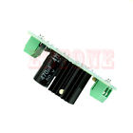**7.5-35V to 5V Power Supply LM7805 L7805 3 Terminals Voltage Stabilizer Regulator**

* **100% brand new and high quality**
* Board size. 56mm*21mm
* Input voltage input voltage polarity, AC and DC can, range. 7.5-20V
* The output voltage 5V
* The maximum output current. 1.2A
* Provided fixed bolt hole, convenient installation
* 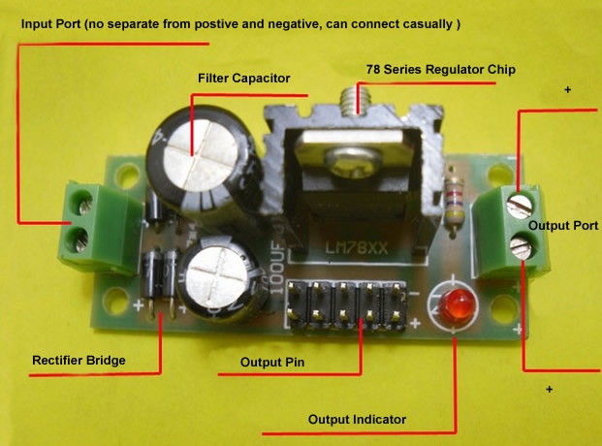
* 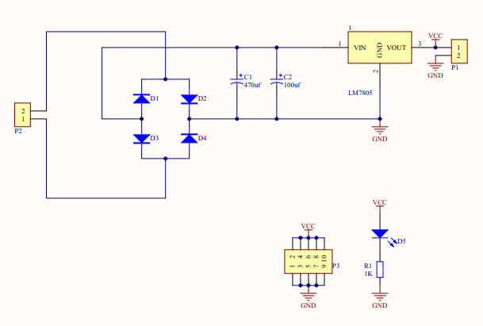

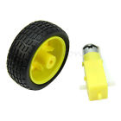**Arduino Smart Car Robot Plastic Tire Wheel with DC 3-6v Gear Motor for Robot**

* **100% brand new and high quality**
* Working Voltage: DC3V ~ 12V (recommended working voltage at around 6 to 8V)
* The maximum torque: 800gf cm min (3V)
* No-load speed: 1:48 (3V)
* The load current: 70mA (3V), 250mA (MAX)
* Motor Size: 70*22*18mm/2.75*0.86*0.7"
* Tire Parameter:
* Center Hole: 5.3*3.66mm/0.2*0.14"
* Wheel Size: approx.66*26mm/2.59*1.02"
* Quantity:1 pc

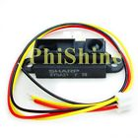**GP2Y0A21YK0F Sharp IR Analog Distance Sensor Distance 10-80CM**

**Description:**

GP2Y0A21YK0F optical sensor, detection distance 10-80cm

Sensing distance:10 ~ 80cm

Output Type:Analog

Voltage – Supply:4.5 V ~ 5.5 V

Current – Supply:30mA

When the voltage is different from the - output difference (typical):1.9V @ 10 ~ 80cm

Different voltages distance - the output (typical value):400mV @ 80cm

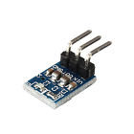**5V to 3.3V DC DC Step Down Buck Module AMS1117 LDO Board**

5V to 3.3V DC DC Step Down Buck Module AMS1117 LDO Board / ESP8266 Power

Features:

Size:8.6mm x 12.33mm

Input voltage: For DC 4.2 V-10 V

Output: 3.3 V, 800 mA

Kindly note:

1.Boost modules or buck module indicate the operating voltage, Please donot exceed operating voltage , or it will be damaged easily !

2.Boost module output voltage can only be greater than or equal to input voltage, cannot be less than the input voltage!

3.Buck module input voltage must be higher than output voltage of 1.5V or 2V, otherwise it can not output enough power!

4.Automatic Adjustable Boost or Buck module has start voltage and limit working voltage, Please donot exceed them , or it will be damaged easily !

5.Cannot reverse polarity , or it will be short circuit, or will be born easily !

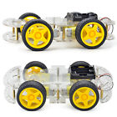**Arduino 4WD DC 6V Smart Car Chassis Robot Kits w/ Speed Encoder**

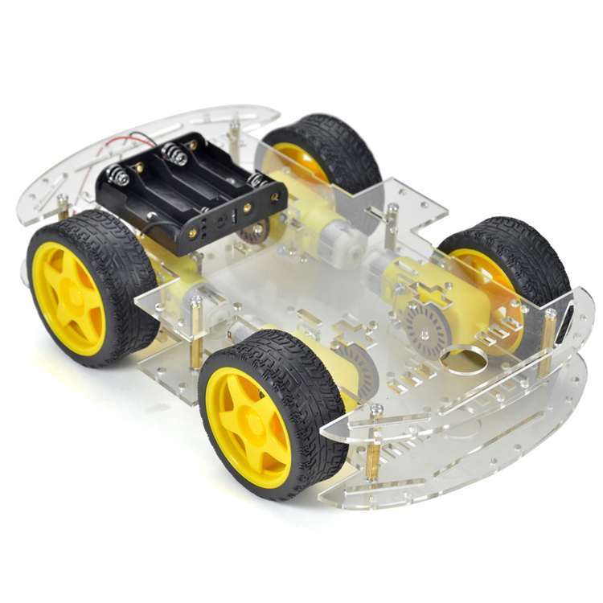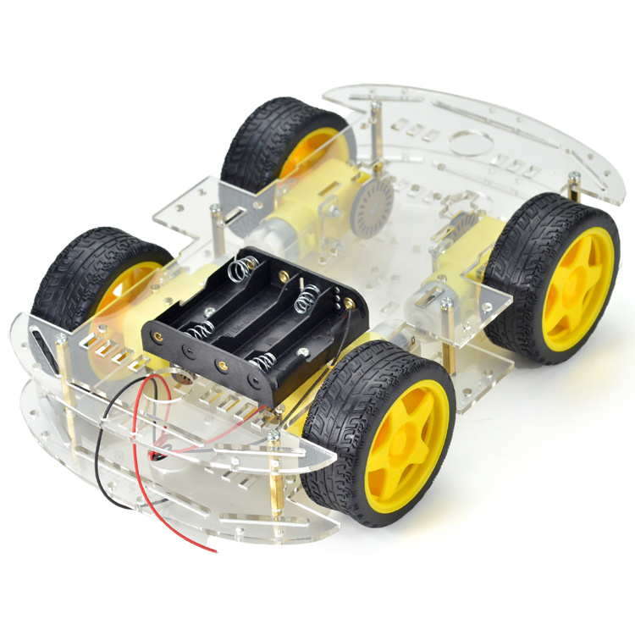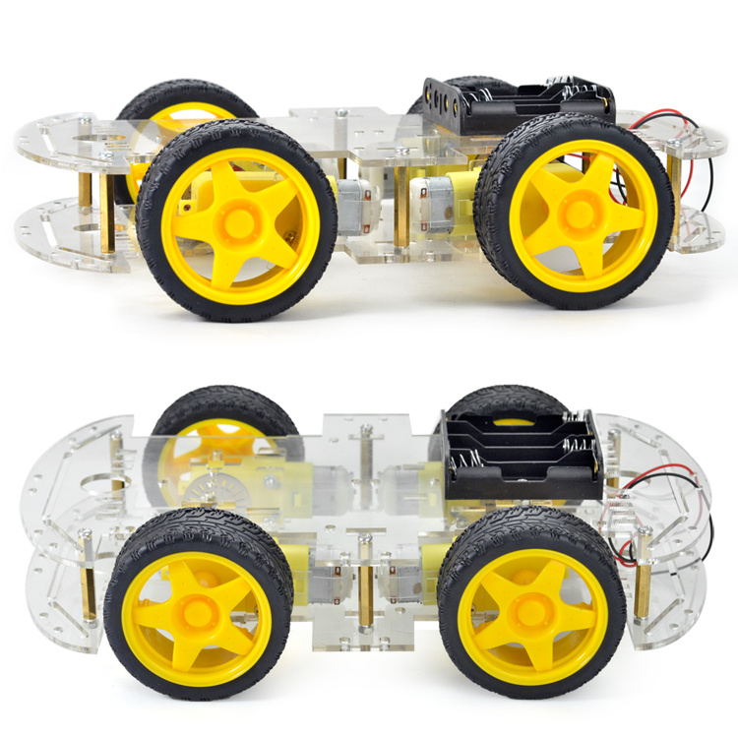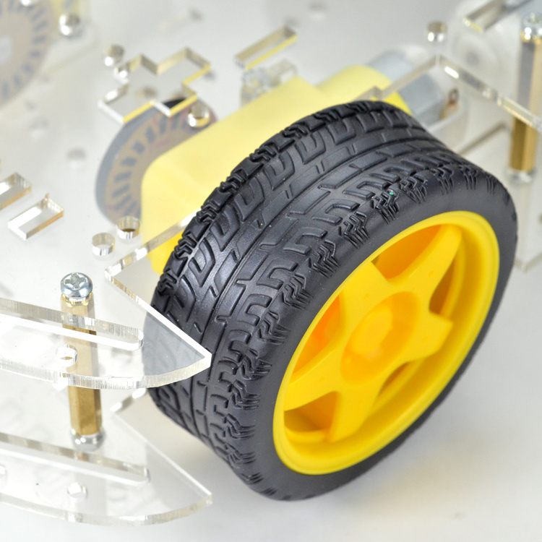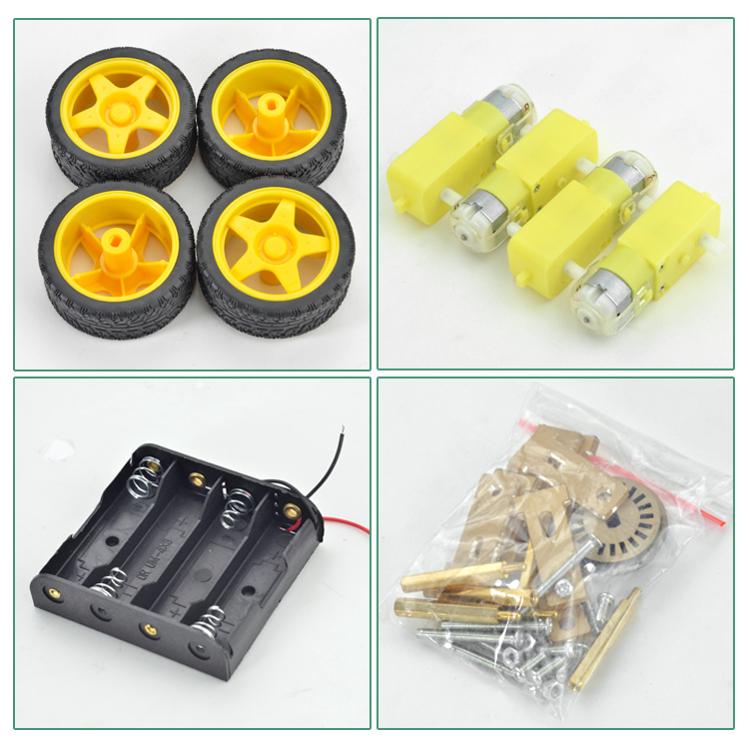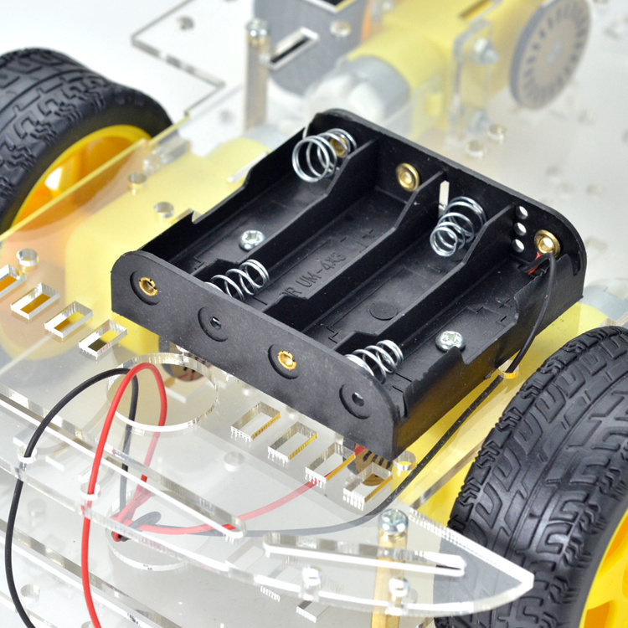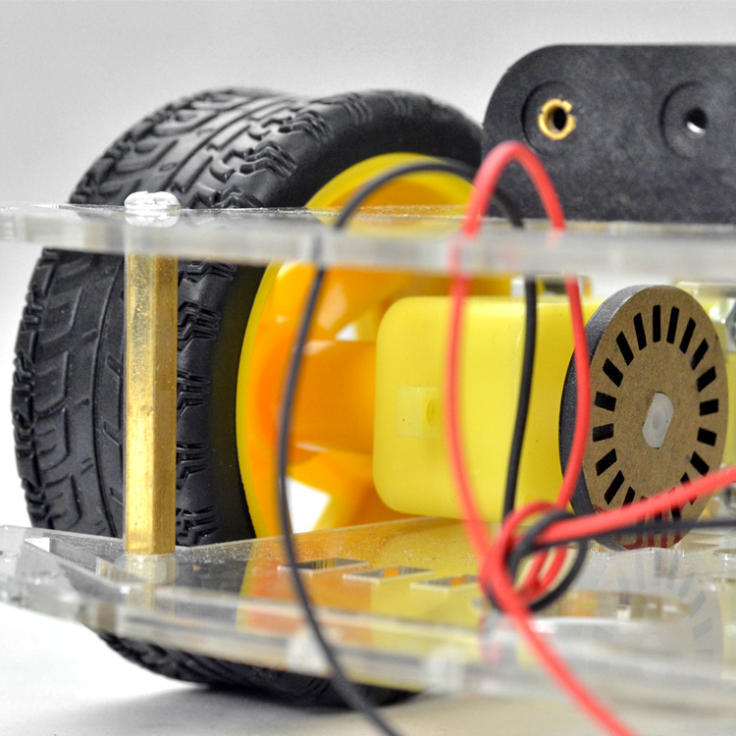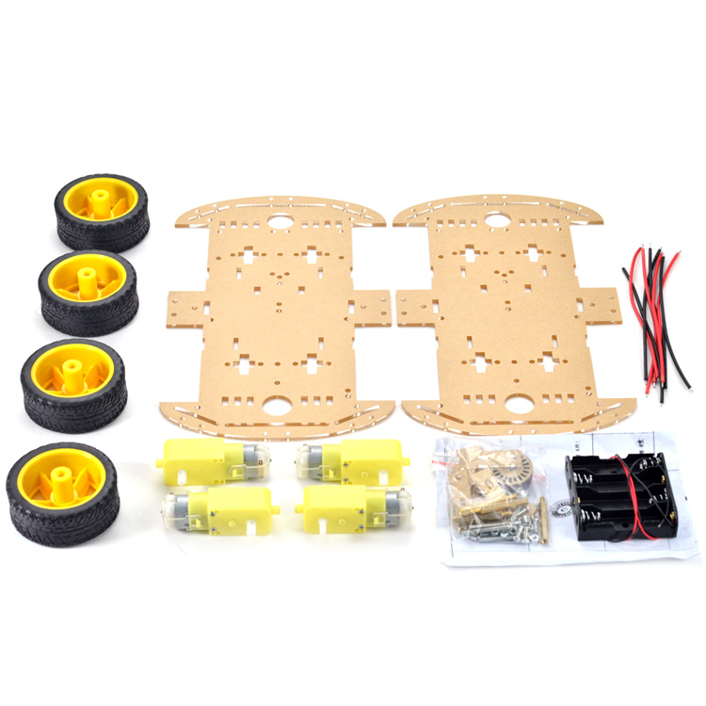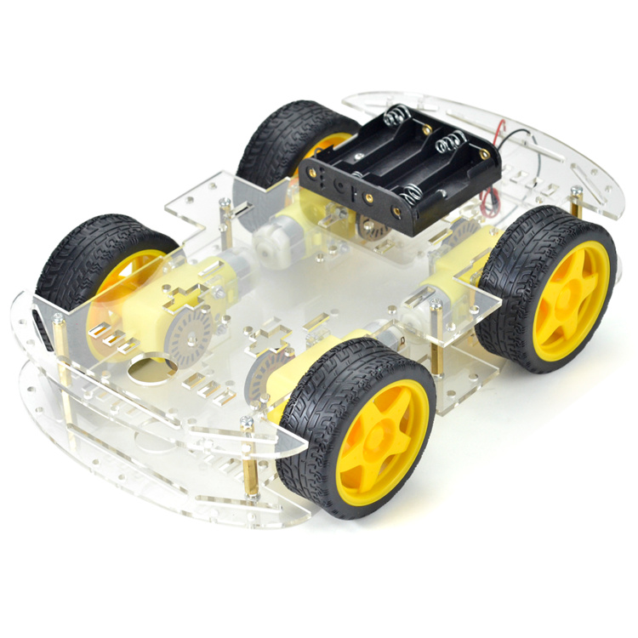

DC 6V 4-wheel Robot Smart Car Chassis Kits car with Speed Encoder for Arduino

• Mechanical structure is simple, very easy to install .

• The car comes with tachometer encoder

• Uses four deceleration direct current machine curve to be nimble, the directivity is good. Four actuations, horsepower fullness. The chassis big and steady very easy to expand

Specification of Motor

| Voltage | DC 6V |
| --- | --- |
| Current | 120MA |
| Reduction rate | 48:1 |
| RPM (With tire) | 240 |
| Tire Diameter | 66mm |
| Baseplate Thickness | 3mm |
| Car Speed(M/minute) | 48 |
| Motor Weight (g) | 50 |
| Motor Size | 70mm*22mm*18mm |
| Noise | <65dB |

Contains:

1x DIY Intelligent Car

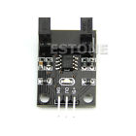**Correlation photoelectric sensor Infrared correlation count sensor**

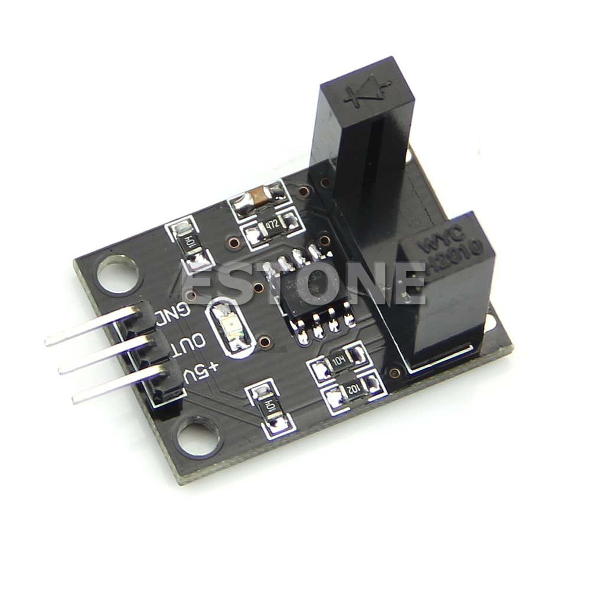

* **100% brand new and high quality**
* Width of optical coupling slot:10mm
* Main chip:LM393,Groove type optocoupler H2010
* Working voltage:DC 5V
* Size:27.6mm x 20mm x 17mm
* Quantity:1PC

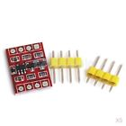**2-Channel Bi-Directional Logic Level Shifter Converters 3V-5V For Arduino**

* Many channels I2C level translator module, IIC UART SPI TTL Bi-Directional level translator module, compatible with 5-3v system
* I2C level translator module, 3V to 5V, 5V to 3V for Arduino
* VIN connected 5V system power supply
* 5A connected 5V system
* 5B connected 5V system
* GND connected 5V system GND
* 3V3 connected 3V system power supply
* 3A connected 3V system
* 3B connected 3V system
* GND connected 3V system GND
* Size (L x W): 16 x 12mm / 0.63 x 0.47 inch

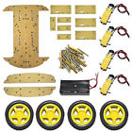**Four Wheel-Drive Smart Robot Car Chassis**

Size: 20 x 16.2 cm car; Drive mode 4 wd chassis:

Thickness: black or transparent organic glass: + / - 5 mm; The motor; Current: date: double spindle; Reduction ratio: 1:48; 5 v load speed: r/min; 5 v load speed: 40 meters per minute; Power substation 2 x 18650 battery (not included) : 6.6 cm; Wheel diameter of 2.6 cm, thick four rounds;

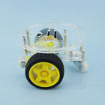**2WD Mini Round Double-Deck Smart ZF Hot Car Chassis DIY Kit for Arduino**

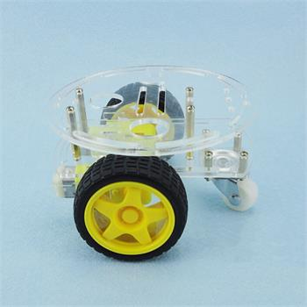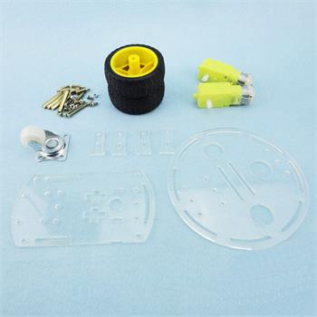

## Description

NOTE: It is DIY kit,not finished product.

Outline Size: 135mm*135mm*80mm

The round acrylic plate diameter: 130mm

Another acrylic plate size: 135mm*75mm

Packing List：

1Pcs round acrylic plate

1Pcs acrylic baseboard

2Pcs 65mm wheel

1Pcs universal wheel

2Pcs gear motor

4Pcs "T"mode fixed motor bracket

12Pcs M3X10mm screw

8Pcs M3 nut

4Pcs M3X12+6mm copper cylinder

4Pcs M3X30mm two-way copper column

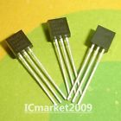**DS2401+ TO-92 DS2401 Silicon Serial Number**

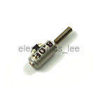**3.9mm*8.5mm 2 phase 4 wire Micro Stepper Motor with 6mm Rod for Arduino Robot**

**Item Description:**

**Features:**

* **Stepper motor diameter: 3.9 MM**
* **Height: 8.5 MM (include bearing sleeve)**
* **Output shaft: 1.7 MM (small Division pole)**
* **Output shaft length: 6 MM**
* **Motor type: Two-phase four-wire**
* 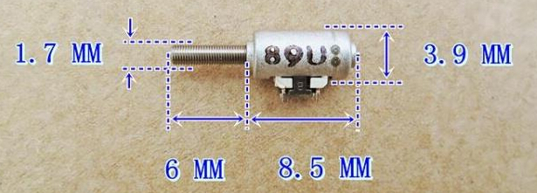

**Package including:**

* **1pcs 3.9mm*8.5mm 2 phase 4 wire Micro Stepper Motor with 6mm Rod for Arduino Robot**

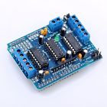**L293D Motor Drive Shield Expansion Board**

* Brand new and high quality.
* L293D is a monolithic integrated, high voltage, high current, 4-channel driver.
* Basically this means using this chip you can use DC motors and power supplies of up to 36 Volts, thats some pretty big motors and the chip can supply a maximum current of 600mA per channel, the L293D chip is also what’s known as a type of H-Bridge.
* The H-Bridge is typically an electrical circuit that enables a voltage to be applied across a load in either direction to an output, e.g. motor.
* 2 interface for 5V Servo connected to the Arduino's high-resolution dedicated timer - no jitter.
* Can drive 4 DC motors or 2 stepper motors or 2 Servo.
* Up to 4 bi-directional DC motors with individual 8-bit speed selection.
* Up to 2 stepper motors (unipolar or bipolar) with single coil, double coil or interleaved stepping.
* 4 H-Bridges: per bridge provides 0.6A (1.2A peak current) with thermal protection, can run motors on 4.5V to 36V DC.
* Pull down resistors keep motors disabled during power-up.
* reset button.
* 2 external terminal power interface, for seperate logic/motor supplies.
* Tested compatible for Arduino Mega, Diecimila & Duemilanove.
* Size:6.8cm x 5.5cm x 2cm - 2.68inch x 2.17inch x 0.79inch.

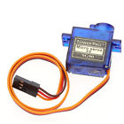**SG90 Micro 9g Servo**

High quality and high cost performance.

All Nylon Gear.

245mm connector wire.

Large stall torgue of 1.6 Kg.

Small size and light weight.

With 3 sets of servo horns and fittings.

Specification:

color: blue

Operating Speed (4.8V no load): 0.12sec/60 degrees

Stall torque: 1.2kg / 42.3oz(4.8V);1.6 kg / 56.4oz (6.0V)

operating voltage: 3.0-7.2V

Temperature range: -30℃~60℃

Dead band width: 7us

Item size: 3.2 * 3 * 1.2cm

Item weight: 9g

Connector wire length: 24.5cm

Package weight: 53g

Package include:

1 x SG90 Gear Micro Servo

1 x 25cm wire

3 x Servo Horns

3 x Screw

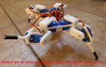**Mini Quadruped | 4 legged robot | 3D Printed Frame for 9g Servos | KIT | GREEN**

Mini Quadruped | 4 legged robot | 3D Printed Frame for 9g Servos | KIT | GREEN

**GREEN MODEL**

**KIT ONLY**

**All 3D Printed Items have already been created and are inventory on hand. No wait, Fast Shipping from USA!**

This auction is for a kit for building a Mini Quadruped | 4 legged robot that is compatible with Arduino. **You will receive the ABS 3D printed parts only.**

· Based off of the Mini Quadruped remixed by TheCase on Thingiverse (thing:38159)

· - Parts made from 3d printed ABS. (Similar to white parts picture above)

· - Printed at 2mm resolution.

· - Multiple colors available in my other auctions.

· - Please remember, this is a 3D printed Hobby grade kit and may contain rough edges.

**Other necessary parts (Not Included):**

· 8x Hitec HS-55 9g Servos or Compatible 9g Servo.

Servo will have to be less than 25mm tall to fit.

Please note - TowerPro Model SG90 / SG92 Micro Servos are too tall (26.3mm).

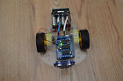**Aurduino Controlled 2WD Robot Platform for Boys and Girls**

This 2WD Arduino controlled Robot Platform comes with the following:

1) Arduino Uno R3

1) Sainsmart Motor Driver Shield

1) HC-SR04 Ultrasonic Sensor (included for future autonomous programing)

1) HC-SR04 Mounting Bracket

1) 2WD Chassis

1) 5 AA Battery Pack (7.5V) (batteries not included)

It can be easily programmed using the Arduino IDE Software. there is also plenty of Open Source Software available online for all types of uses for the Arduino Uno R3.

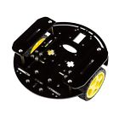**Smart Car Robot With Chassis And Kit (Black Round, Arduino Control, New, USA)**

**Message us for high quantity order.**

Features:

• 3mm Black Acrylic Chasis

• Kit and Motor Are Included.

• Motor Operating Voltage: 3V - 8V

• Motor Maximum Torque: 1.5kg.cm at 7.2V

• Motor Speed Without Load: 250rpm/m at 7.2V

• Motor Load current: 250mA at 7.2V

Size:

6.7" x 6.2" x 2.9"

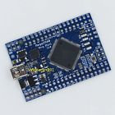**Small Meduino Mega2560 R3 Pro Mini ATMEGA16U2 (Arduino Mega2560 Compatible**

Introduction:

This **Meduino Mega2560 Pro Mini** board is a small version of the Mega2560 board. It's completely compatible with the original Arduino Mega2560. For the original Mega2560 it has a big board size, some time it maybe not easy to embed it into your system, the Meduino Mega2560 Pro Mini board will be more easy for embedding it into your system. It's cute and small size.

Features:

1. Completely compatible with original Arduino Mega2560
2. Pin pitch: 0.1 inch
3. Size: 5.42cm*3.68cm
4. With Atmega16U2 chip as the USB to Serial converter
5. 5V working voltage.
6. Input Voltage:7-12V
7. Analog Input Pins: 16
8. Digital I/O pins: 54

Package Include:

1. 1pcs Meduino Mega2560 Pro Mini board
2. 1pcs 2*40 2.54mm male header

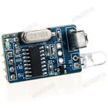**5V Infrared IR Remote Decoder Encoding Transmitter&Receiver Wireless Module Hot**

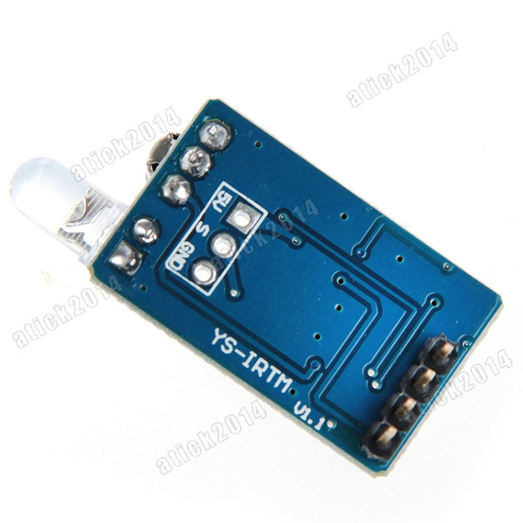

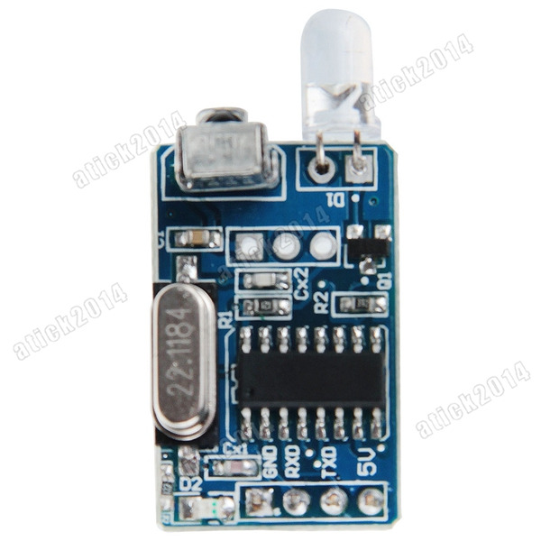

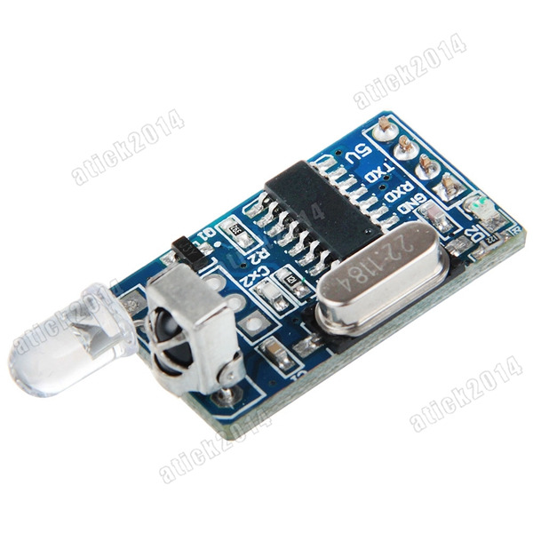

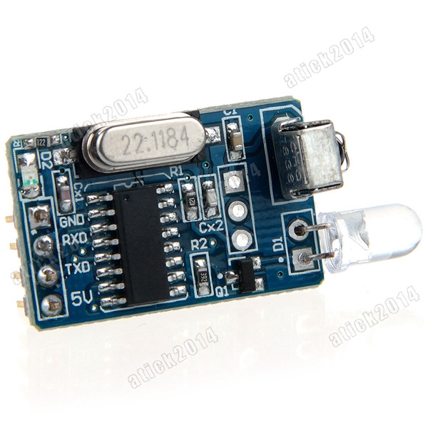

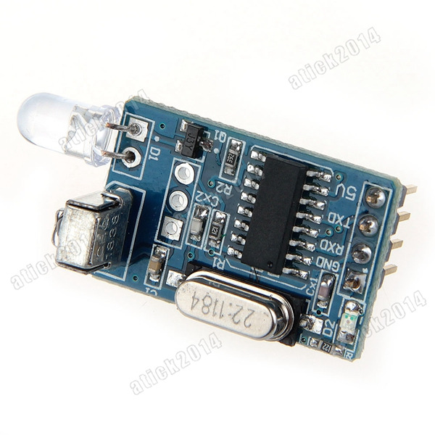

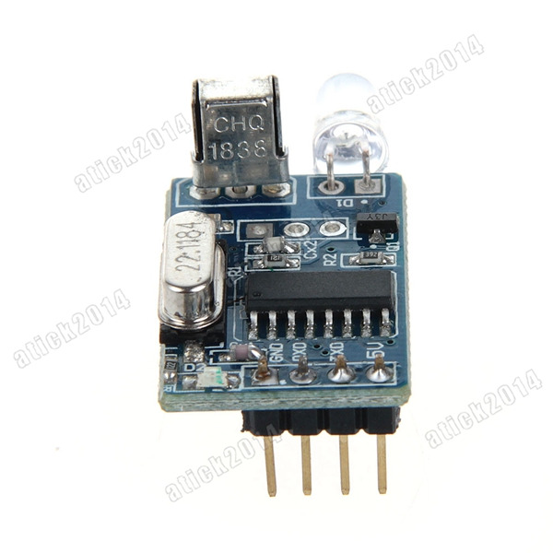

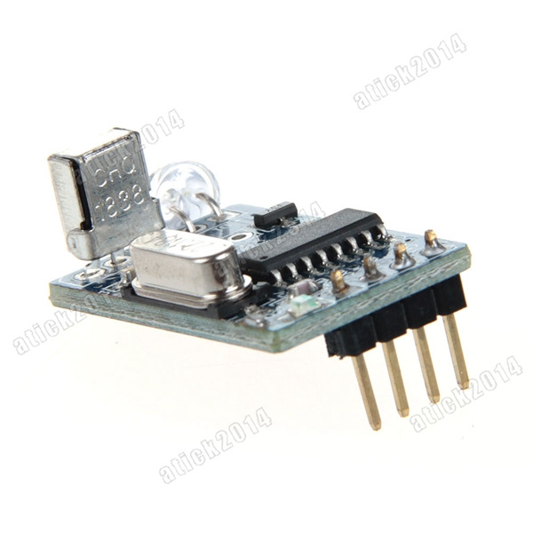

**IR decoding, encoding module / infrared communication module / infrared transceiver, wireless**

**Baby parameters:**

**1. Specification: 27''17MM**

**2. supply voltage: 5V**

**3. Communication: Serial communication (TTL level)**

**4. firing distance: 6-10 meters (OUR actual environmental testing eight meters Stability Control)**

**Function:**

**1. with the infrared emission features.**

**2. with infrared encoding.**

**3. with the infrared emission head expansion interface.**

**4. with serial communication functions, communication level is TTL.**

**5. can control 99% of the infrared format devices, including televisions, fans and other electrical and electronic equipment.**

**6. support for encoding chips :( typical encoding chips such as uPD6121, uPD6122, TC9012 and numerous compatible chip model, such as the PT2221, PT2222, SC6121, SC6122, SC9012, etc.)**

**7. can be used as an infrared wireless data communication, data transmission, control and other functions IR**

**Applications:**

**Smart home, student electronic design, infrared turn wireless, intelligent industrial equipment, MP3 controller, IR remote control, IR decoding equipment, electronic building blocks kit, electronic equipment control, infrared wireless switch design, coding equipment intelligent infrared remote control car.**

**Package Content:**

**1xIR codec module**

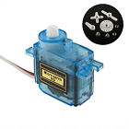**Micro 9g RC Servo for Trex 450 Futaba Hitec HS-55 Align GWS JR Walkera HG**

# **Description:**

Features:  
New SG90 9G Micro / Mini Servos + Horns For Helicoper Airplane  
Translucent Body  
Light Weight  
Less Noise  
Connector Wire Length 150mm  
  
Specification:  
Dimensions: 22.6 x 21.8 x 11.4mm  
Operating Speed (4.8V no load) : 0.12sec / 60 degrees  
Stall Torque (4.8V): 1.98 kg/cm  
Temperature Range: - 30 to + 60 degree C  
Dead Band Width: 4usec  
Operation Voltage : 3.5 - 8.4 Volts  
Recommend Model: Mini Car / Mini Ship / Helicopter & Airplane  
Original box: NO  
Net weight: 13g  
Package weight: 19g  
Color: blue  
  
Package Content:  
1 x SG-90 9g RC Airplane & Helicopter Micro Servo (with accessories)

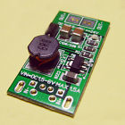**5W USB DC-DC Converter Step Up Module 5V to 12V Power Supply Boost Module**

100% brand new and high quality 5V to 12V Power Supply Boost Module

Start Voltage: DC1V

Operating voltage: DC1-6V

Maximum power: 6W

Maximum efficiency: 90%

Volume: 16 * 33MM

No-load Efficacy: 3-15MA

Maximum output voltage: 20V

Maximum input current: 1.5A

Minimum operating voltage: 1.5V

Low start-up current: 90MA

Package included: 1 piece 5V to 12V Power Supply Boost Module

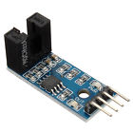**Groove Type Optocoupler Motor Speed Measuring Counter Sensor Module**

**LM393 Speed Sensor Detection Speed Module For Arduino**

**Features:**

Working voltage: 3.3V~5V

Weight: 8g

Dimensions: Approx.3.2 x 1.4 x 0.7cm

5mm Groove width

Using wide voltage LM393 comparator

Application: Widely used in dynamo speed detecting, pulse counting, etc

Output form: Digital switch output (0 and 1) and Analog for Sensitivity.

**Package included:**

1 x Speed sensor

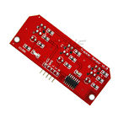**5V 3-way Tracking Tracing Module Hunt Modules Sensor Robot Accessories**

* 3 road sensors tracing, make necessary robot
* Using infrared detection, strong anti-jamming capability
* CTRT5000 sensor adopts, high sensitivity, stable performance
* Working voltage 5V, white lines output low level
* With delicate do manual work, with indicator
* With fixed bolt hole and easy installation
* Quantity:1pc

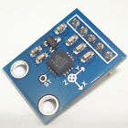**GY-61 ADXL335 3-axis Analog Output Accelerometer Module**

**GY-61 ADXL335 3-axis Angular Transducer Accelerometer Module Analog Output**

**Features**

Chip: ADXL335.

Power supply: 3-5V

X, Y, Z output

**Package includes:**

1*ADXL335 Angular Transducer Module

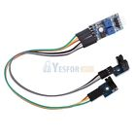**2-way Speed Sensor Module Counting Modules Motor Speed Groove Coupler Module**

100% Brand new and high quality .

Applications: Widely applied to motor speed detection, pulse counting, position limit, with 2 channels test.

Main features:

Adopt imported groove type optical coupling sensor

Width of groove: 5mm

With output indicator, the indication light will be off for output high level and on for output low level.

Output low level when blocking out, output high level when without blocking out.

Comparator output, clean signal, good waveform, strong drive ability, exceed 15mA.

Working voltage: 3.3V-5V

Output type: Digital switch output (0 and 1)

With fixed screw holes, convenient to mount

PCB size: 3.2cm x 1.7cm

Using wide voltage LM393 comparator

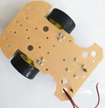**Two wheel robot platform (used)**

This is a set of two wheel robot platform. The picture is the taken from the actual unit for auction here.